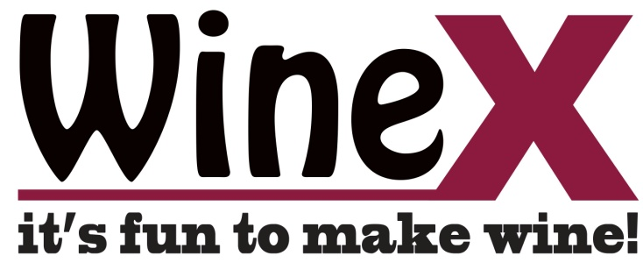
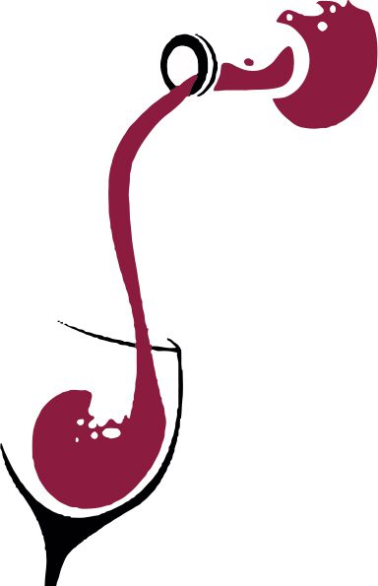
First time client coupon!
There’s no Xcuse not to give wine making a try today!

$20.00 off
First batch of any
Regular priced wine kit
(including brew on premise service)

809 Victoria St. N
Kitchener, Ontario
519-571-9704
www.winexcuse.ca

